Policy Management System
Software Requirements Document
V 1.0


 | Prepared By | Reviewed by | Approved By
Name | Rajeshwar Chary
Role | Team member | Project Leader/ Team Leader/ Team Member | Project Manager/ Team Leader
Signature | VS
Date | 11/13/2014

Table of Contents
1 Introduction 3
1.1 About this document 3
1.1.1 Purpose & Scope of the document 3
1.1.2 Intended Audience 3
1.2 About the Software System 3
1.2.1 Purpose 3
1.2.2 Scope of the system 3
1.2.3 Exclusions 4
1.2.4 System Perspective 4
1.2.5 System diagram 5
1.2.6 System Environment 5
1.2.7 User Characteristics 6
1.2.8 Impact of the System 6
1.2.9 Assumptions, Risks / Constraints 6
1.2.10 Design Constraints 6
2 System Requirements 7
2.1 Functional Requirements 7
2.1.1 User Registration Module 7
Policy Registration Page 10
User Policy Registration Page 13
2.1.2 Search Policies Module 14
Search Policies Page 14
2.1.3 Search Policies Module 15
2.1.4 Policy Payment Module 17
2.1.5 Policy Payment Module 17
2.2 Nonfunctional Requirements 19
2.2.1 UI Requirements: Inn 19
2.2.2 Performance Requirements: Pnn 19
2.2.3 Installation, Deployment & Operational Requirements: Onn 19
2.2.4 Maintainability & Portability Requirements: MPnn 19
2.2.5 Security Requirements Snn: 19
3 Requirements / Use Case Summary Table 20
4 Make /Buy analysis 22
4.1 Reusable components 22
5 Annexure 22
6 Change Log 22

Introduction

About this document

Purpose & Scope of the document
The purpose of the software requirements document is to systematically capture requirements for the project and the system “Policy Management System” to be developed. Both functional and non-functional requirements of this system are captured in this document. It also serves as the input for the project scoping
The scope of this document is limited to addressing the requirements from a user, quality, and non-functional perspective. It is recommended that design aspects are not added in this document

Intended Audience
Project Team

About the Software System
The following section will cover aspects related to Policy Management System will allow end user to manage policies with ease.

Purpose
Policy Management System (PLMS) is basically a system that helps to maintain the Policies and Payments. It also allows to search a Policy.
The following are the modules in this proposed system
a) User Registration.
b) Policy Registration.
c) Edit Policy Registration.
d) Search Policies.
- Policy Payment.

Scope of the system
The scope of the system is explained through its modules as follows
  - User Registration - User should submits the details into the system.
  - Policy Registration- Policy Registration be used by the admin to register the policies. The system will generate the policy id and if it is a valid policy the system will store the details in the database.
  - Edit Policy Registration- To edit the policy details of a customer.
  - Search Policies- Search policies. The system will provide a search engine mechanism to find the policies. This will access the database by getting the details based on user search criteria.
  - Policy Payment - The policy Payment be used by the user to make Payments for their policies.

Use Case Diagram

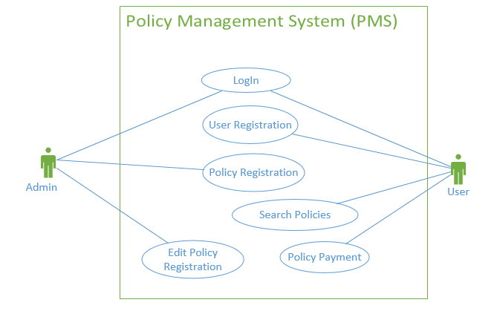

Exclusions
- The system will operate only on the modules discussed above and will not include any additional functionality.

System Perspective
The PLMS is an independent software system developed to manage the activities like Policy registration, User registration, Edit policy, etc. using the Java/Dotnet architecture.

System diagram
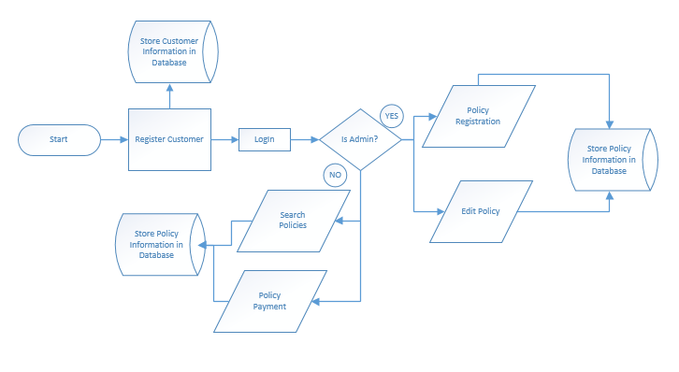

Architecture diagram

Physical Architecture:
A physical architecture is an arrangement of physical elements, (system elements and physical interfaces) that provides the designed solution for a product, service, or enterprise. It is intended to satisfy logical architecture elements and system requirements. Auto Identification Process follows a three layered architecture namely presentation layer, business logic layer and data access layer.
- Presentation Tier is the tier in which the users interact with an application. Presentation Tier contents Shared UI code, Code Behind and Designers used to represent information to user.
- Business Tier is mainly working as the bridge between Data Tier and Presentation Tier. All the Data passes through the Business Tier before passing to the presentation Tier. Business Tier is the sum of Business Logic Layer, Data Access Layer and Value Object and other components used to add business logic.
- Data Tier is basically the server which stores all the application’s data. Data tier contents Database Tables, XML Files and other means of storing Application Data.
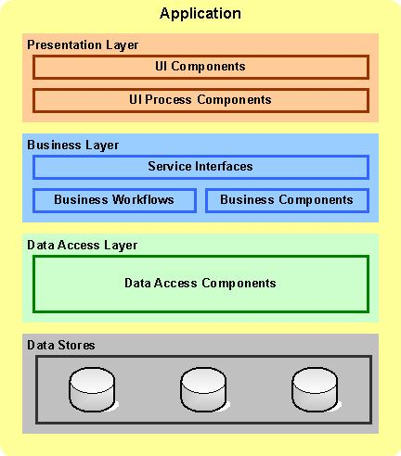

Logical Architecture:
The Logical Architecture defines the Processes (the activities and functions) that are required to provide the required User Services. Many different Processes must work together and share information to provide a User Service. The Processes can be implemented via software, hardware, or firmware. The Logical Architecture is independent of technologies and implementations.
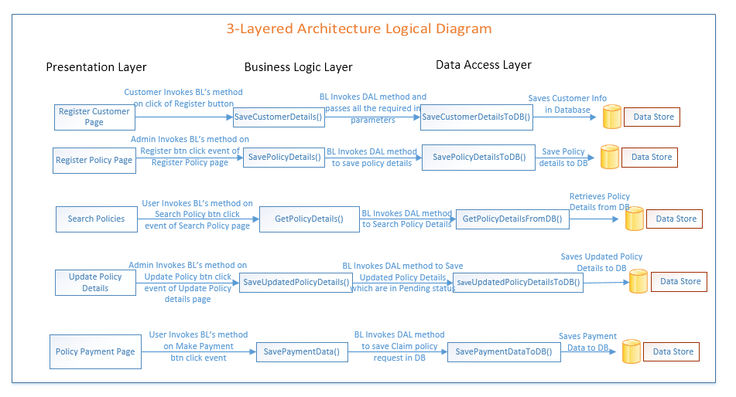

System Environment
The PLMS application will be operated from the client server with parallel processor support. When a user connects to the Web Server, the Web Server will interact with the Database after processing the business logic to transfer data to and from a database.
- Java/J2EE or .NET Framework application deployment.
- My SQL/SQL server database for data storage

User Characteristics
The application should be user friendly; in such a way that the user would not need any software and hardware knowledge. The user may be new to the client products having never used them before.
The types of users likely to use the system are as follows,
- Client
- Delivery Assurance Group, Process Engineering group
- Developers, testers, other associates in the project

Impact of the System
This is a new product which is developed for internal users. Expected impact of the product is to automate existing manual processes in order to make them more efficient and cost effective.

Assumptions, Risks / Constraints
Assumptions:
- The processing admin must possess prior knowledge on PLMS operations undertaken offline.
- The admin should have the details of the policies and customers to be registered /updated into the system.
Risks:
- If there is any failure in policy payment processes, the system should be able to handle such a financial risk.

Design Constraints
- The User modules and the Policy modules should remain independent, without affecting the policy payment operations.
- Application should have single login feature. Login functionality should be the welcome feature for the application.
- Only administrator can access the application.
- None of the application features can be accessed without login.

System Requirements

Functional Requirements

Home Module
Policy Management System  Req-2.1.1 | Home Page
Functional Requirements
When the users enter the following link http://localhost:8080/PolicyManagementSystem in the browser, Home page appears which will have a short welcome message; a brief introduction to the purpose of the Policy Management System, the user can choose appropriate options.
Under home page, we need below interface.
Home page Interface Requirements
- Admin
- User
- About Us
- Contact Us

Customer Registration Module
Policy Management System Req-2.1.1.1 | Customer Register Page
Functional Requirements
When the User/Customer clicks on the registration link, it should re-direct to registration form and the user need to fill some of the basic attributes/fields as mentioned below in requirement;
User Name ,Password, First Name, Last Name, Age, Gender (Male or Female) ,Contact Number
E-mail, Address, Pin code, City.
At any given point of time, the user can Deselect/Reset all or can go to home page by the clicking home.
User Interface Requirements
  - First name - Name of the user
  - Last name -Name of the father
  - Date Of Birth- User DOB in DD/MM/YYYY format
  - Address- Address of the User
  - Contact no- Contact number of the Applicant
  - Email Address- Email Address of the User
  - Qualification- Educational qualification of the user
  - Gender- Gender of the user
  - Salary- Salary per month
  - PAN No- Pan Card Number
  - Employer type- Type of the Employer
  - Employer- Name of the Employer if Salaried or Optional
  - Hint Question- Hint question for recovery of password
  - Hint Answer- Answer for the question
  - There should be 2 buttons i.e. Register, reset
Trigger
- User triggers the functionality once he/she submits the details into the system.
Pre-Conditions
- The system should collect all the required details for User Registration.
Post Conditions
- System should generate the user id and decide the eligibility based on date of birth and income.
Success End Condition
On successfully saving the details the message should be displayed in this format:
Dear User,
Your User Id is <userId> and your password is <password>.
Failed End Condition
- The system should throw an error message if any one or more of the validations fail. The error messages and error codes need to be identified during design. The validation and business rules are mentioned in the business rules section.

Steps & Actions
- System should get the all the required information from the user.
- Identify the eligibility based on the age and income. Age can be calculated with the help of Date of Birth.
- Users above 18 to 60 years are only eligible in the system
- Identify the user type as follows

Income per year  (in lakhs) | User type
5 | A
10 | B
15 | C
30 | D
More than 30 | E

- Generate the User id as follows.
User id is <USERTYPEID>-XXXX

Fetch the last generated user id to identify the new number. But the last generated user id has to be retrieved separately from the database for each user type.

(Example: if the value for user type B is B-1200 in USER_REGISTRATION table, then 1200 will be taken and 1 will be added. So the next record’s user id will be B-1201.)
- Generate the password as follows.
Password = (current date (dd))+(current month (mmm) ) + (# or _ or $) +unique random 3 digit number
Example: 02apr_234, 03may$452
Note: Special character should be any of this (# or _ or $) that can be decided randomly.
Make sure the last random 3 digits number should not be duplicated.
- Validate the PAN card number as follows.
PAN Card is XXXXXNNNNX
Example: BDIRA1528N
Note: First five will be alphabets and 4th and 5th will be the first and last name’s first characters
Next four letters will be digits and last letter is the letter from the date of birth month’s first letter.
Business Rules & Validations
- All the information’s are mandatory.
- User Name should be alphabets and numeric and name should starts with alphabet.
- Email id should have special character _ and dot (.)
- Contact should contain number.
- Gender needs to be selected.
- PAN Card number should be validated.
- Date of birth cannot be after the current date.
- Email id should not exist in the system.
- If Employer type is self-employed, company should not be entered.
- If Employer type is salaried, company should be entered.

Policy Registration Module
Policy Management System Req-2.1.3.1 | Policy Registration Page
Functional Requirements
Administrator needs to register the policy details of a customer into the system. The administrator should have the policy details of the customers to be entered into the system.
User Interface Requirements
- Policy name- Name of the Policy
- Start Date- Start date in DD/MM/YYYY format
- Duration in years- Duration in years
- Company- Company name
- Initial deposit- Amount to be deposited at start
- Policy Type- Type of the policy
- User Types- User types available for policy
- Terms per year- Number of Payment Terms per year
- Term amount- One term’s payment amount
- Interest- Interest for the policy
- There should be 2 buttons i.e. Register Policy, reset

Trigger
Admin triggers the functionality once he/she submits the details into the system
Pre-Conditions
- The system should collect all the required details for Policy Registration.

Post Conditions
- System should generate the policy id and calculate the end date based on the duration provided.
Success End Condition
On successfully saving the details the message should be displayed in this format:
Dear Admin,
The policy is successfully register
The policy <policy id> is available to the users from <policy start date> to <policy end date>.
This is the <n>^{th} policy in the <policy type>. To add more Click <Policy Registration>.
Failed End Condition
- The system should throw an error message if any one or more of the validations fail. The error messages and error codes need to be identified during design. The validation and business rules are mentioned in the business rules section.

Steps & Actions
- System should get the all the required information from the admin.
- Identify the eligibility based on the start date and duration provided.
- Policy start date should be on or after current date
- Policy types can be one of the below
    - Vehicle Insurance
    - Travel Insurance
    - Life insurance
    - Health Insurance
    - Child Plans
    - Retirement Plans
- Generate the Policy id as follows.
Policy id is <POLICYTYPEID>-<YEAROFPOLICYSTART>-XXX

Fetch the last generated policy id to identify the new number. But the last generated policy id has to be retrieved separately from the database for each policy type.

(Example: if the value for policy type is ‘Child Plans’ and start date is 15-07-2014 means that the last id generated in the policy type is CP-2014-005 in POLICIES table, then 005 will be taken and 1 will be added. So the next record’s Policy id will be CP-2014-006.)
- Generate the maturity amount as follows.
Maturity amount = (initial deposit) + (duration * term_in_years * term amount) + ((duration * term_in_years * term amount) * (interest /100))
Business Rules & Validations
- All information is mandatory.
- Policy Name should be alphabets.
- Start date should be on or after the current date.
- Duration should contain number.
- Company Name can be alphanumeric.
- Initial deposit should contain number.
- Policy type needs to be selected.
- User types needs to be selected.
- End date and maturity amount should be calculated

Edit Policy Registration Page
Policy Management System Req-2.1.3.1 | Edit Policy Registration Page
Functional Requirements
Administrator needs to edit the policy details of a customer.
User Interface Requirements
This should capture the following details
After successfully validation of the details, System should generate the policy no.
- Policy Name- Name of the Policy
- Policy Type – Represents the policy Type
- Duration – Duration of the policy
- Policy Amount – Represents the policy amount.
Update all the details in the database.

Trigger
- Admin triggers the functionality when he/she needs to edit the policy.
Pre-Conditions
- A Policy should have been already registered in the system.
Post Conditions
- System should successfully save the updated policy details.
Success End Condition
Display a success message policy has been updated successfully.
Failed End Condition
- The system should throw an error message if any one or more of the validations fail. The error messages and error codes need to be identified during design. The validation and business rules are mentioned in the business rules section.
Steps & Actions
- If the admin clicks edit button, policy name, Policy Type, Duration, Policy amount fields should be editable.
- Now calculate the new policy interest, Policy End Date and Update these editable details into the system.
Business Rules & Validations
- All information is mandatory.
- Policy id should be proper format.
- Policy Start date should be on or after the current date.
- User should not have policies more than 2 in each policy type.
- Policy registration only accepted if the term amount per year which the user paying (including his/her other policies with the current policy selected) should be less than 40% of the total yearly income of user.
- End date and maturity amount should be calculated

Search Policies Page
Policy Management System Req-2.1.5 | Search Policies Page
Functional Requirements
This Module will be used by the user to search the policies. The system will provide a search engine mechanism to find the policies. This will access the database by getting the details based on user search criteria.
User Interface Requirements
This should capture the following details
- Number of years- Number of years
- Company Name- Company Name
- Policy Type- Type of the policy
- Policy Id- Policy Id
- Policy Name- Name of the Policy
- There should be 2 buttons i.e. Search Policy, reset

Trigger
- User triggers the functionality once he/she submits the details into the system.
Pre-Conditions
- The system should collect all the required details for Policies to be searched.

Post Conditions
- System should show the complete details about the polices.

Success End Condition
- On successful search the details and the message should be displayed in this format:
Dear User,
You are eligible for the below policies.
Policy Id: <Policy Id> | Policy Name: <Policy Name> | Initial deposit amount
Description:<Policy description>
This policy duration is <duration in years> and for each year <terms per year> terms you have to pay the amount Rs. <term amount> with interest of <interest>%. The maturity amount will be provided after period of policy will be Rs. <maturity amount>

Please Click <Search Policies > for changing the search criteria.
- In case more than one is returned, the same table should be displayed every time with details of each policy(e.g., if there are two policies returned then two tables should be displayed with each table displaying the details of each policy).

Failed End Condition
- The system should throw an error message if any one or more of the validations fail. The error messages and error codes need to be identified during design. The validation and business rules are mentioned in the business rules section.

Steps & Actions
- System should get the all the required information from the user.
- Identify the eligible policies for the user based on the search criteria provided by the user.
- Policies should be active in order to be shown to display
- The search criteria should accept any one the following
  - Policy Type
  - Number of years
  - Company Name
  - Policy Id
  - Policy Name

- Fetch the details of polices and show accordingly. If no policies found for the user display user friendly messages.

Business Rules & Validations
- Either one of the information is mandatory.
- Policy id should be validated in a proper format like <POLICYTYPEID>-<YEAROFPOLICYSTART>-XXX.
- Number of years should contain number.
- Company Name can be alphanumeric.
- Policy type needs to be selected.
- Policy name is only alphabets.
- Policy name based search will return all policy names which contain either the entire match are a partial match

Policy Payment Page
Policy Management System Req-2.1.6 | Policy Payment Page
Functional Requirements
This Module will be used by the user to make Payments for their policies. The system will generate the bill id and if it is a valid payment then the system will store the details in the database.
User Interface Requirements
- Policy Id : Policy Id
- Bill Date : Current date in DD-MM-YYYY format
- Payment Amount : Amount paid for the policy
- Fine : Fine calculated based on bill date
- Due date :Actual Due date of the policy in DD-MM-YYYY format.
- There should be 2 buttons i.e. Payment, reset.

Trigger
- User triggers the functionality once he/she submits the details into the system.
Pre-Conditions
- The system should collect all the required details for Policy Payment.

Post Conditions
- System should generate the bill id and calculate the balance due based on policy provided.

Success End Condition
- On successfully saving the details the message should be displayed in this format:
Dear Customer,
The payment for your policy is successfully paid. Your bill id is <bill id>.
The next due date for the policy is <due-date > and the remaining balance due
is <due amount>.
To make payment to other policies, click the link <Policy Payment>.

Failed End Condition
- The system should throw an error message if any one or more of the validations fail. The error messages and error codes need to be identified during design. The validation and business rules are mentioned in the business rules section.

Steps & Actions
- System should get the all the required information from the user.
- Identify the due amount based on the policy and current date provided.
- Due date should be on or before current date
- If the bill date is after the due date there should be fine amount should be added based on Policy types
Policy Type | Fine Percentage
Vehicle Insurance | 5
Travel Insurance | 4.5
Life insurance | 4
Health Insurance | 4
Child Plans | 4.75
Retirement Plans | 2.5

- Generate the bill id as follows.
Bill id is <POLICYID>-< (ON|WF)>-XXX

Fetch the last generated bill id to identify the new number. But the last generated bill id has to be retrieved separately from the database for each policy’s payment.
ON means payment made on or before the due date
WF means payment made after the due date with fine

(Example: if the value for policy id CP-2014-006 and the last payment bill id is CP-2014-006-ON-012 then for the current payment without fine made will have the bill id as CP-2014-006-ON-013.)
- Calculate the balance due amount and the due date for the next payment.
- If the payment is the last payment then display the information all the payments are done for the policy and display the maturity date and maturity amount

Business Rules & Validations
- All information is mandatory.
- Policy Name should be in alphabets.
- Start date should be on or after the current date.
- Duration should contain number.
- Company Name can be alphanumeric.
- Initial deposit should contain number.
- Policy type needs to be selected.
- User types needs to be selected.
- End date and maturity amount should be calculated

Nonfunctional Requirements

UI Requirements: Inn
- The front end should be user-friendly and pleasant
- Any error message or exception displayed to the user should be user-readable (and not technical)
- All entered values should be validated
- The UI screens are designed with any theme color along with the logo of the company.
- Exceptions should not be shown on console.
- No debug message should come on console.
- All the errors and exceptions should be logged to log file.
- Log file path should be configurable.
- Database connections should be configurable.
- It should not be hard coded.
- Requirements involving UI features should be taken care in console accordingly

Performance Requirements: Pnn
- All front-end pages should be served up in less than 5 seconds post click when up to 1000 users are on the application concurrently.
- Since it’s a financial operations application, transactions should be safe and fast.

Installation, Deployment & Operational Requirements: Onn
- Application Java and J2EE deployment with My SQL database or SQL Server database for persistence
Or
Application .NET Framework deployment with SQL Server database for persistence
- This system must be up 24X7

Maintainability & Portability Requirements: MPnn
- If the allocated memory space for the existing application needs to be increased then it should be possible without any impact to performance

Security Requirements Snn:
- No unauthorized users should be able to log on to the system
- User Id/Login Id should have combination of letter and numeric values, none of the special characters are allowed (#,@,$,%,&).
- Validate the user id/login id and password, accordingly to the user it will redirect to the appropriate page.

Requirements / Use Case Summary Table
Business Requirement ID | Software Requirements ID | Short Description | Requirement Provider (Originator) | Priority | Complexity | Requirement type | Remarks
BR001 | SR001 | User Registration Module | Client | High | Medium | UI screen & backend processing | -
BR002 | SR002 | Policy Registration Module | Client | Medium | Medium | UI screen & backend processing | -
BR003 | SR003 | Edit Registration Module | Client | High | Medium | UI screen & backend processing | -
BR004 | SR004 | Search policies Module | Client | Medium | Medium | UI screen & backend processing | -
BR005 | SR005 | Policy Payment Module | Client | High | High | UI screen & backend processing | -

Make /Buy analysis

Reusable components
The PLMS can be made reusable as such to handle various other Policies procedures as it forms the base for working on activities that involve billing procedures online.

Annexure
NA

Change Log
Please note that this table needs to be maintained even if a Configuration Management tool is used.
Version Number | Changes made
V1.0 | First version developed by Rajeshwar chary V on Nov 14 2014.
V1.1 | <If the change details are not explicitly documented in the table below, reference should be provided here>
V1.1 | Page no | Changed by | Effective date | Changes effected
V1.2 | <If the change details are not explicitly documented in the table below, reference should be provided here>
V1.2 | Page no | Changed by | Effective date | Changes effected

